
William Jewell College
PAYROLL DEDUCTION FORM

NAME: _____________________________________________________________________
DEPARTMENT: ______________________________________________________________

POSITION: __________________________________________________________________

I wish to join the Faculty and Staff community investing in our students with my gift to:

Jewell’s Greatest Need (Jewell Fund)
Cardinal Athletic Fund (Athletics)
Nursing Excellence Alumni Scholarship

Other: _________________________

My gift(s) to Jewell will be made as a:

Payroll Deduction Amount: _________

Monthly Quarterly Annually

One-time deduction of $_________

Credit Card**

Visa MasterCard Discover American Express
Name on Card: ____________________________________
Card #___________________________________________
3-Digit CID# ___________ Exp. Date _________________
One-time gift of $________ by check.

As a sustaining member, I/we wish to join the:

John Priest Greene Society through my annual support of the Jewell Fund
J Club through my annual support of the Cardinal Athletic Fund.

This gift is being made:

as a joint gift. Please recognized us as ____________________________________

anonymously.

My spouse works for a matching gift company. Please contact me for more details.

Signature _______________________________________________ Date _______________
*Deduction(s) begin on the next pay period upon receipt unless otherwise specified.
**Deduction(s) begin on the 15th of the next month upon receipt.

Annual Giving Societies

Jewell Fund
Supporting the current needs of the College and provides student scholarships.

John Priest Greene Society
Leadership donors who share an annual commitment of $1,200 or more to the Jewell Fund in support of the advancement of Jewell’s mission.

Cardinal Athletic Fund
Supporting the enhancement of Jewell’s student-athletic experience, including sports medicine, strength and conditioning, equipment management, and recruitment.

J Club
A network of alumni, families, and friends committed to advancing Cardinal Athletics with an annual commitment of $500 or more to the
Cardinal Athetlic Fund.

Fan Club $500 - $999
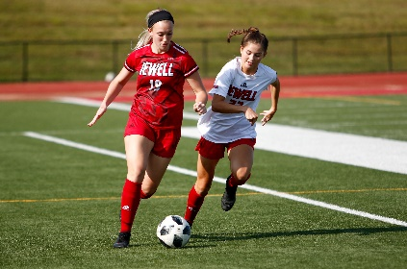
Varsity Club $1,000 - $2,499
Captains Club $2,500 - $4,999
Cardinal Club $5,000 - $9,999
Champion Circle $10,000 +

Please send your completed form to Megan Carraher, Director of Annual Giving at carraherm@william.jewell.edu or through interoffice mail to the Office of Institutional Advancement Box 1032. Questions? Call Megan at 816.415.7684.

